Type of Cell | Image of Cells | Sketch of Cells | Properties of Cells
Animal  Motor Neuron (nerve) | 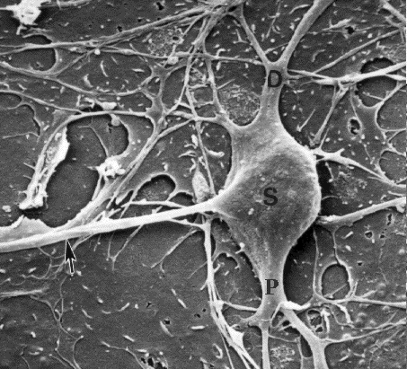  Electron Micrograph | 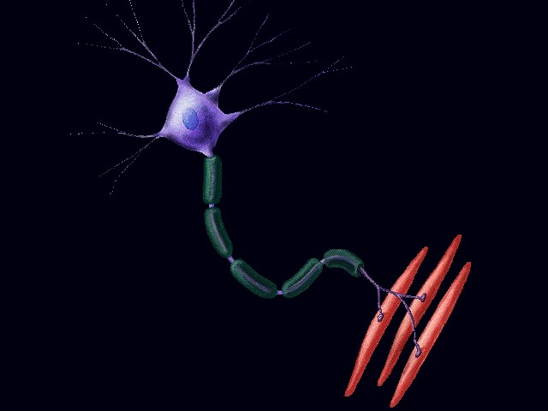 | - cell membrane- surrounds entire cell- soft  - soma (cell body)- circular- gelatinous (squishy)-definite form  - dendrites- cablelike, multiple branches  - axon- thicker cable with small bulb strutcures along the way.
Animal  Red Blood cell (and platelet, white blood cell) | 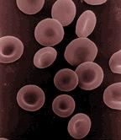  Micrograph | 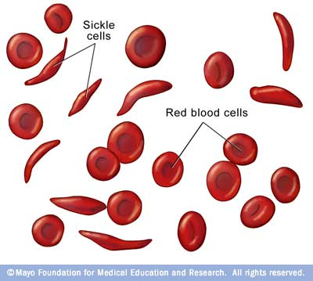 | - cell membrane- surrounds entire cell- soft  - cell body- doughnutlike shape (no hole in the middle)- gelatinous (squishy)
Animal  Bone Cell | 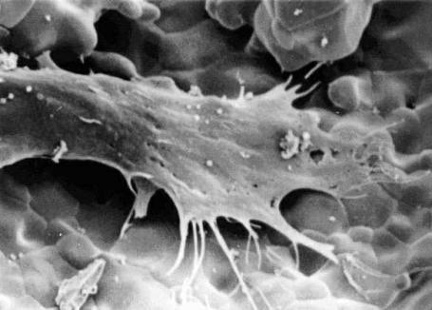  Micrograph | 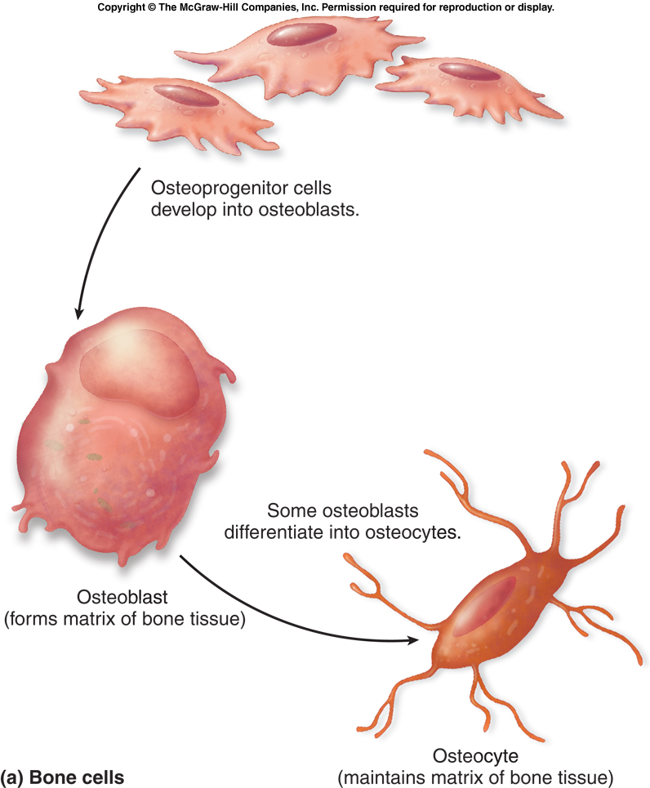 | - cell membrane- surrounds entire cell- soft  - cell body- a star shaped cell, large central body, firm tennacles attach itself to the rest of the bone
Animal  Smooth muscle | 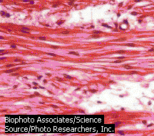  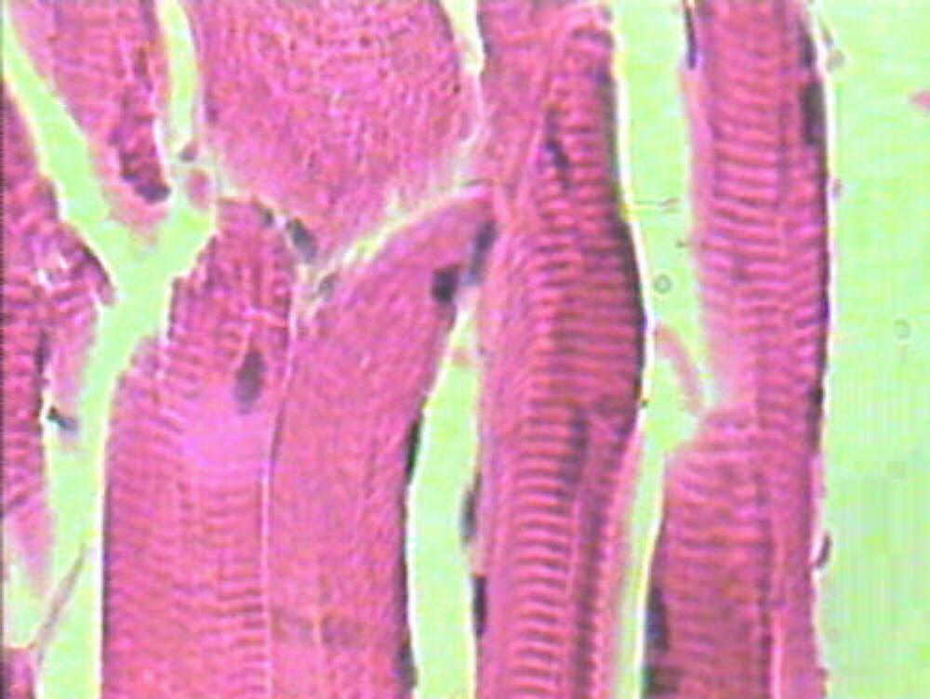 | 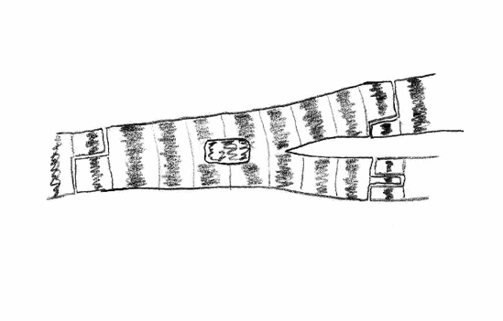  Smooth Muscle | - cell membrane- surrounds entire cell- soft  - cell body- branched cylinder-repeating visible striations (dark bands)
Plant  Stoma-Guard Cells | 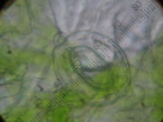  Microscope low power | 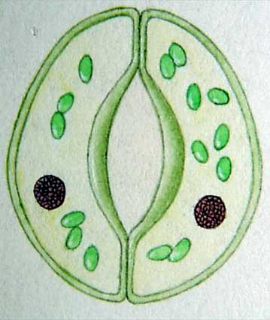 | - Cell wall- surrounds entire cell-hard  - Guard cells occur in pairs and are shaped so that a pore, or stoma, exists between them.
Plant  Elodea | Microscope 400x 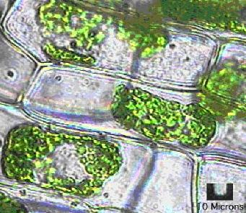 | 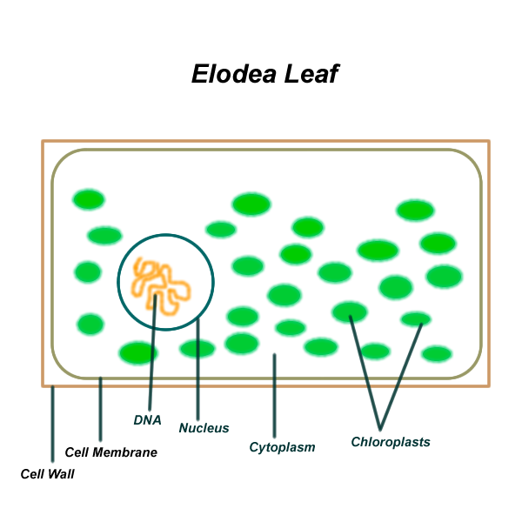 | - Cell wall- surrounds entire cell-hard  - Cell body- rectangular in shape- closely packed
Plant  Cork Cambium | 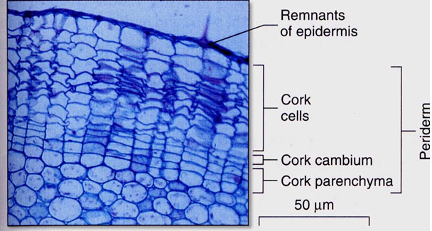 | 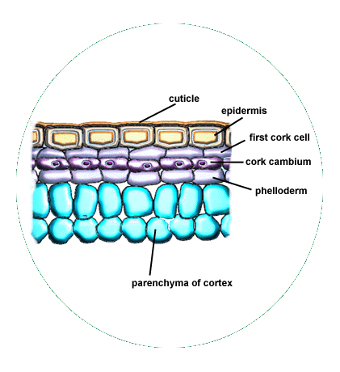 | - Cell wall- surrounds entire cell-hard  - Cell body- Rounded rectangles, flattened ovals  - They are loose and disorganized cells
Plant  Palisade Cell | 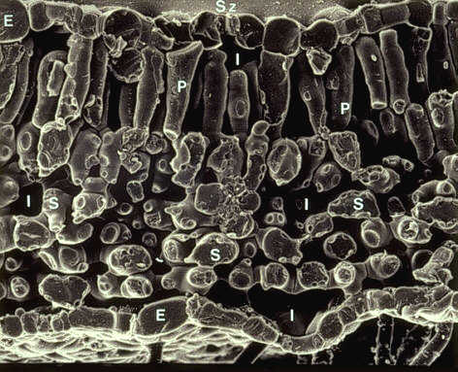  Scanning Electron Microscopic | 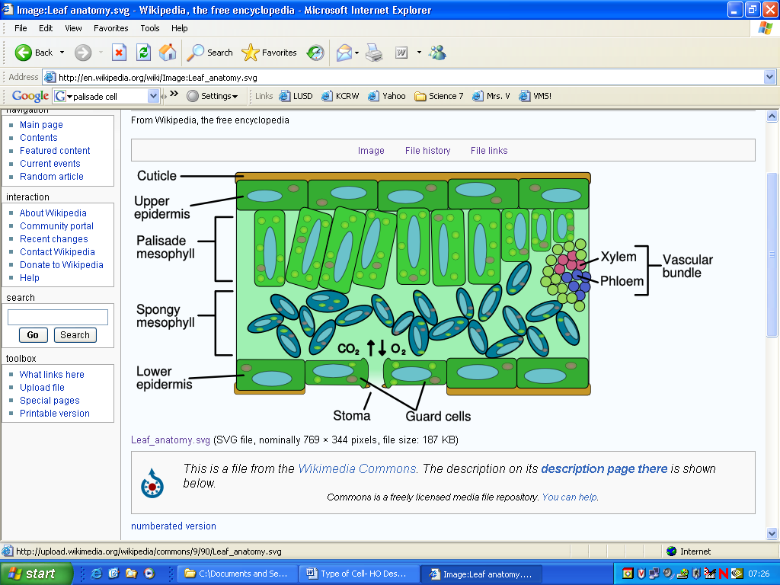 | - Cell wall- surrounds entire cell-hard  - Cell body- cylindrical shape and are packed into the leaf.

